Novel Biodegradable Ester-Based Polymer Blends with Ethylcellulose

Jolanta Yasin¹, Richard Guillet², Hartwig Meyer^{*1}

¹ Polymer Science Institute, University of Pisa, Via Appia 11, 56126 Pisa, Italy; E-mail: hmeyer@psi.uni-pisa.it
² Institute of Macromolecular Chemistry, National Academy of Sciences of Ukraine, Kharkovskoe shousse 48, Kiev 02160, Ukraine

Keywords: biodegradation; blends; enzymes; poly(3-hydroxybutyrate)

Summary: Two PHB/EtC (poly(3-hydroxybutyrate)/ethylcellulose) blends (80/20 and 50/50 w/w) were selected for biodegradation experiments in activated sludge and in enzymatic solution of PHB-depolymerase from Pseudomonas lemoignei and from Aureobacterium saperdae. Blend morphology was quite different: blend 80/20 was composed of a matrix of impinging PHB spherulites with dispersed EtC inclusions, whereas blend 50/50 was constituted of two continuous phases with interpenetrated domains. Both blends biodegraded in activated sludge but only blend 80/20 was attacked by PHB-depolymerases from P. lemoignei and A. saperdae.

1. Introduction
Recently poly(3-hydroxybutyrate) and related bacterial poly(hydroxyalkanoates) (PHA) have attracted much attention as biocompatible and biodegradable thermoplastic polymers [1]. Degradation of PHAs occurs both in vivo through hydrolysis of the ester linkage, and in an accelerated fashion in the environment, due to the intervention of extracellular enzymes produced by microorganisms present in soil and water [2-4].
2. Morphology
Microtomed sections of PHB/EtC blends (80/20 and 50/50) were observed between the crossed polars of an optical microscope (Figure 1).
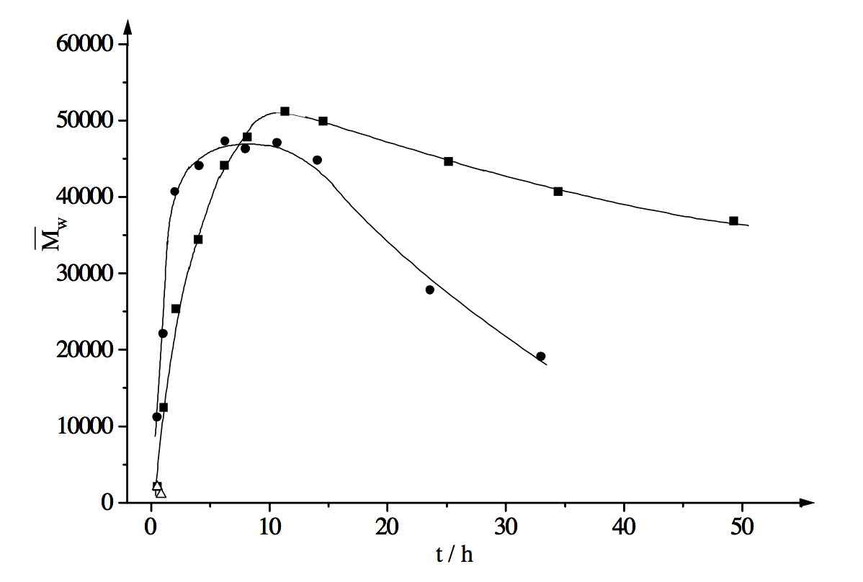
Figure 1. Weight-average molecular weight

The micrograph of blend 80/20 (Figure 1) shows a large spherulite which nucleated on the film surface and grew across the whole film thickness (the dark area across the film represents one of the arms of the maltese cross). All over the section of blend 80/20, black spots are observed, that were attributed to phase-separated amorphous EtC. The morphology of this blend was confirmed by optical microscopy (OM) observations of isothermally crystallized samples (Table 1).

Table 1. Thermal properties of PHB/EtC
Head 1 [units]^{a)} | Head 2 | Head 3 | Head 4 | Head 5 [units]
Column 1 | Column 2 | Column 3^{b)} | Column 4 | Column 5
Column 1 | Column 2 | Column 3 | Column 4 | Column 5
^{a)} Table Footnote; ^{b)} Table Footnote.

2.1. Second-Order Heading
Microtomed sections of PHB/EtC blends (80/20 and 50/50) were observed between the crossed polars of an optical microscope (Figure 1). The micrograph of blend 80/20 (Figure 1) shows a large spherulite which nucleated on the film surface and grew across the whole film thickness (the dark area across the film represents one of the arms of the maltese cross).
2.1.1. Third-Order Heading
Microtomed sections of PHB/EtC blends (80/20 and 50/50) were observed between the crossed polars of an optical microscope (Figure 1). The micrograph of blend 80/20 (Figure 1) shows a large spherulite which nucleated on the film surface and grew across the whole film thickness (the dark area across the film represents one of the arms of the maltese cross).
3. Conclusion
Microtomed sections of PHB/EtC blends (80/20 and 50/50) were observed between the crossed polars of an optical microscope (Figure 1). The micrograph of blend 80/20 (Figure 1) shows a large spherulite which nucleated on the film surface and grew across the whole film thickness (the dark area across the film represents one of the arms of the maltese cross).
Acknowledgements
((Acknowledgements, general annotations, funding. Other references to the title/authors can also appear here, such as “Author 1 and Author 2 contributed equally to this work.”))

References
[1] ((Journal articles)) a) A. B. Author 1, C. D. Author 2, Adv. Mater. 2006, 18, 1; b) A. Author 1, B. Author 2, Adv. Funct. Mater. 2006, 16, 1.
[2] ((Work accepted)) A. B. Author 1, C. D. Author 2, Macromol. Rapid Commun., DOI: 10.1002/marc.#########.
[3] ((Books)) H. R. Allcock, Introduction to Materials Chemistry, Wiley, Hoboken, NJ, USA 2008.
[4] ((Edited books or proceedings volumes)) J. W. Grate, G. C. Frye, in Sensors Update, Vol. 2 (Eds: H. Baltes, W. Göpel, J. Hesse), Wiley-VCH, Weinheim, Germany 1996, Ch. 2.
[5] ((Presentation at a conference, proceeding not published)) Author, presented at Abbrev. Conf. Title, Location of Conference, Date of Conference ((Month, Year)).
[6] ((Thesis)) Author, Degree Thesis, University (location if not obvious), Month, Year.
[7] ((Patents)) a) A. B. Author 1, C. D. Author 2 (Company), Country Patent Number, Year; b) W. Lehmann, H. Rinke (Bayer AG) Ger. 838217, 1952.
[8] ((Website)) Author, Short description or title, URL, accessed: Month, Year.
[9] …((Please include all authors, and do not use “et al.”))

